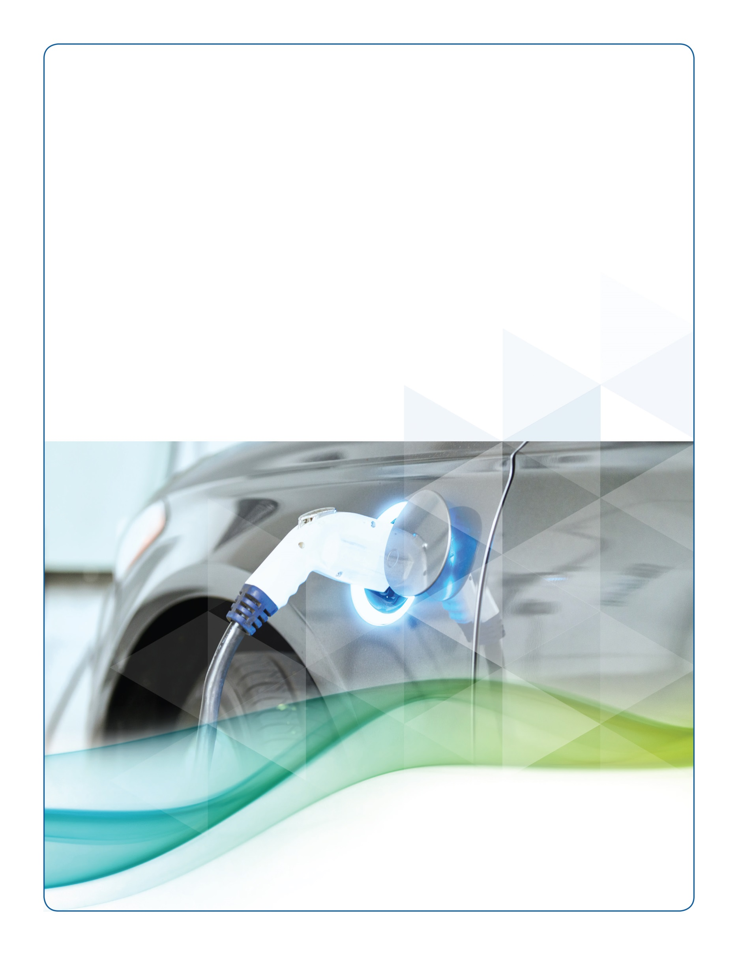
San Diego Regional Alternative Fuel
Assessment
March 2015
Prepared for
San Diego Association of Governments
In Support of
California Energy Commission Award ARV-13-013
Prepared by
Center for Sustainable Energy on behalf of San Diego Regional Clean Cities Coalition

This document was prepared as a result of work sponsored by the California Energy Commission. It does not necessarily represent the views of the Energy Commission, its employees, or the State of California. The Commission, the State of California, its employees, contractors, and subcontractors make no warranty, express or implied, and assume no legal liability for the information in this document; nor does any party represent that the use of this information will not infringe upon privately owned rights.

Contents
1. Executive Summary 6
2. Purpose 7
3. Previous Regional Alternative Fuel Planning Efforts 8
Familiarity with Alternative Fuels 9
4. State and Municipal Strategies 11
State Strategies 11
Status of the State Alternative Fuels Plan 13
Status of Bioenergy Action Plan 15
Status of Executive Order B-16-2012 15
Local Climate and Sustainability Planning 16
San Diego Region Greenhouse Gas Reductions 19
5. Codes and Standards 20
Alternative Fuel Station Installation Codes and Standards 21
Biodiesel and Ethanol 21
Electric Vehicle Charging Stations 21
Hydrogen 21
Natural Gas 22
Propane 22
California Green Building Code 23
Zoning and Parking 24
6. Infrastructure 26
Infrastructure Coverage 28
7. Vehicles 30
Alternative Fuel Vehicles in Local Fleets 35
8. Incentives 38
Heavy-Duty Vehicles 38
Hybrid and Zero-Emission Truck and Bus Voucher Incentive Project 39
San Diego County Air Pollution Control District 39
Light-Duty Vehicles 40
9. Alternative Fuel Investments 42
California Energy Commission Funding 42
U.S. Department of Energy Funding 44
Private Funding 45
10. Training 46
Municipal Staff Training 47
11. Outreach and Education 48
12. Data Limitations 49
13. Alternative Fuel Barriers 49
14. Conclusion 50
Appendices 52
Appendix A: Refuel Membership List
Appendix B: Regional Alternative Fuel Vehicle and Infrastructure Barriers
Appendix C: Public Agency Alternative Fuel Survey
Appendix D: Local Fleet Alternative Fuel Survey

List of Figures
Figure 3-1: Familiarity with Alternative Fuels Among Public Agencies 9
Figure 3-2: Familiarity with Alternative Fuels Among Adopting Fleets 10
Figure 4-1: Public Agency Respondents’ Familiarity with State Strategies 12
Figure 4-2: Alternative Fuels and Alternative Fuel Vehicles Fuel Use as a Percent of Total Fuel Demand 14
Figure 4-3: Preliminary Forecast of On-Road PEVs 16
Figure 5-1: CALGreen Timeline 23
Figure 5-2: Public Agency Respondents with Alternative Fuel Zoning Codes/Ordinances 25
Figure 6-1: Public Alternative Fuel Stations San Diego County, 1991-2014 27
Figure 6-2: San Diego County Public Level 2 Electric Vehicle Charging Stations 28
Figure 7-1: Light-Duty Registered Alternative Fuel Vehicle Populations California, 2000-2012 31
Figure 7-2: New Alternative Fuel Light-Duty Vehicle Sales San Diego County, 2010-2014 32
Figure 7-3: New Medium- and Heavy-Duty Vehicle Sales San Diego County, 2010-2013 33
Figure 7-4: San Diego Regional Alternative Fuel Vehicle Sales and Gasoline Prices 34
Figure 7-5: Estimated Cumulative PEV Sales San Diego County, 2010-2014 35
Figure 7-6: Number of Alternative Fuel Vehicles from SDRCCC Stakeholders 36
Figure 7-7: Yearly Gallons of Gasoline Equivalent Reduced by SDRCCC Stakeholders 37
Figure 8-1: Number of HVIP Vouchers San Diego County, 2010-2014 39
Figure 8-2: CVRP Funding in San Diego Region, 2010-2014 41

List of Tables
Table 4-1: Alternative Fuel-Oriented Strategies 11
Table 4-2: San Diego Regional Alternative Fuel Strategies 18
Table 4-3: Theoretical San Diego Regional Petroleum Reduction Goals 20
Table 5-1: 2013 CALGreen Intervening Cycle Update 24
Table 6-1: Alternative Fuel Station Coverage 29
Table 7-1: Motivations for Adoption by Adopting Fleet Respondents 37
Table 8-1: Proposition 1B Goods Movement Emissions Reduction Program Projects in the San Diego Region 40
Table 8-2: Carl Moyer Voucher Incentive Program Projects in the San Diego Region 40
Table 9-1: ARFVTP Funding: Awards Given to Projects in San Diego Region 43
Table 9-2: Anticipated 2015 ARFVTP Statewide Funding 43
Table 11-1: San Diego Regional Clean Cities Coalition Workshops and Events, 2012-2014 48

1. Executive Summary
The San Diego Regional Alternative Fuel Readiness Assessment (Assessment) provides an overview of the current state of alternative fuels in the San Diego region in order to better inform the creation of a regional alternative fuel readiness plan and related resources. The Assessment draws from three main influences: existing conditions, survey results, and the regional alternative fuel barriers table.
This Assessment addresses the following alternative fuels: biodiesel, electricity, ethanol (flex fuel/E85), hydrogen, natural gas (CNG/LNG), and propane autogas (LPG). These fuels offer a realistic alternative to traditional gasoline and diesel fuels, and support local, state, and federal efforts to reduce greenhouse gas (GHG) emissions, criteria air pollutants, and dependence on imported petroleum.
Identifying the existing conditions of alternative fuels in the San Diego region establishes a baseline of information and serves as a starting block for the development of sector-specific toolkits to support local governments in their efforts to better understand their role in the deployment of various alternative fuels. The Assessment details alternative fuel use in the San Diego region, including, but not limited to, past regional alternative fuel planning efforts, incentives and investment for alternative fuel projects, and current alternative fuel vehicles and infrastructure in the region.
Survey results provide the Assessment with information on the level of alternative fuel awareness and usage characteristics of public and private fleets in the San Diego region. The alternative fuel barriers table identifies the current obstacles that the San Diego region faces, including educational, technical, and financial barriers. The barriers table provides recommendations for overcoming the noted barriers. These recommendations were developed in response to the survey results, existing conditions research, and input from Refuel: San Diego Regional Alternative Fuel Coordinating Council (Refuel).
The Assessment highlights the San Diego region’s current alternative fuel ecosystem in a number of ways. First, while the San Diego region has made noticeable progress in the adoption of alternative fuels, they equate to a small portion of the region’s overall total fuel use. Light-duty flex fuel vehicles and plug-in electric vehicles (PEVs), in particular, have been growing steadily in number; however, 80 percent of the region’s light-duty vehicles use conventional gasoline. Second, the San Diego region has benefitted from over nine million dollars in State investment, in terms of grants and vehicle rebates, for alternative fuel projects. Third, alternative fuel infrastructure is limited in number but covers a large portion of the regions business and residents. Finally, public agencies and fleet managers need more information on the technical and economic aspects of fuels to integrate these alternatives into their plans and operations.

2. Purpose
With funding awarded by the California Energy Commission (Energy Commission), the San Diego region will expand upon previous regional planning efforts specific to PEVs, broadening them to include all alternative fuels. Led by the San Diego Association of Governments (SANDAG), in partnership with the San Diego Regional Clean Cities Coalition (SDRCCC) and the San Diego Air Pollution Control District (SDAPCD), the goal of this collective effort is to develop a comprehensive alternative fuel readiness plan drawing on the expertise and input of Refuel, which is made up of diverse stakeholders from local and regional public agencies, industry, fleet managers, and other interested parties (full member list is found in Appendix A).
The Assessment provides a benchmark with which to evaluate the role of alternative fuels, identify the needs of local public agencies and fleet managers, and to help prioritize the efforts of the Refuel for the San Diego region. Specifically, attention is paid to biodiesel (B20), electricity, ethanol (E85 and flex fuel vehicles), hydrogen, natural gas (compressed natural gas, CNG or liquid natural gas, LNG), and propane (liquefied petroleum gas or autogas, LPG). The Assessment brings awareness to the barriers impeding increased alternative fuel use in the region, which largely involve education, alternative fuel infrastructure, and alternative fuel vehicles.
Through the Assessment’s discussion of the alternative fuel landscape, Refuel will create a framework for a regional alternative fuel readiness plan. In particular, Refuel will help inform the design and functionality of alternative fuel sector-specific toolkits, which are part of the readiness plan. The toolkits are intended as a reference guide for local governments and stakeholders in the region. Each toolkit will vary based on the audience using the recommendations set forth in this Assessment.

3. Previous Regional Alternative Fuel Planning Efforts
On-road transportation accounts for 44 percent of the San Diego region’s GHG emissions. In order to help the state meet the Global Warming Solutions Act (Assembly Bill (AB) 32, Statutes 2006) targets, which established a goal to reduce statewide emissions to 1990 levels by the year 2020, the region has proactively taken steps to reduce petroleum usage and provide more fuel choices. The region has completed several projects in support of this goal.


In an early effort to address the increasing desire to use alternative fuels, SANDAG drafted the Alternative Fuel Vehicle and Infrastructure Report in 2009 (2009 Report). The 2009 Report provided an overview of alternative fuel infrastructure in the San Diego region, presented recommendations for local governments to integrate alternative fuels into their fleets, and encouraged local governments to support the greater deployment of these vehicles. This Assessment acts as an update to the 2009 Report.
PEVs now hold one percent of the region’s passenger vehicle market
As the 2009 Report was wrapping up, both SDG&E and SANDAG entered into Memorandums of Understanding (MOUs) with Nissan North America pledging to support making the San Diego region one of the first plug-in ready regions in the nation. As part of this effort, local outreach events were held and the San Diego region was selected to be one of the first five metropolitan areas in the United States for the introduction of PEVs through the EV Project (see more in Alternative Fuel Investments).
The Center for Sustainable Energy (CSE) conducted the first baseline assessment of the PEV landscape in San Diego, funded by a U.S. Department of Energy (DOE) grant in 2012. This baseline assessment included the results of surveys given to local governments to determine whether their existing permit processes and building codes supported PEV growth.
In 2012, the Energy Commission awarded SANDAG funding to plan for the growth of PEVs in the San Diego region. This funding established the PEV coordinating council, named the San Diego Regional Plug-in Electric Vehicle Infrastructure (REVI) working group, to develop the San Diego Regional Plug-in Electric Vehicle Readiness Plan (PEV Readiness Plan). The PEV Readiness Plan includes fact sheets, resources, best practices, and other pertinent guidance documents for use by planners and other local government officials to support the growth of PEVs in their jurisdiction.

Familiarity with Alternative Fuels
As a result of past regional efforts with alternative fuel planning, public agencies and local fleets have been well-exposed to a variety of alternative fuels. In the Public Agency Alternative Fuel Survey (Public Agency Survey), respondents expressed varying levels of familiarity across a range of alternative fuel types, with the highest level of familiarity with electricity. In contrast to the strong familiarity with electricity, there was very little familiarity with hydrogen (Figure 3-1).
  - Figure 3-1: Familiarity with Alternative Fuels Among Public Agencies
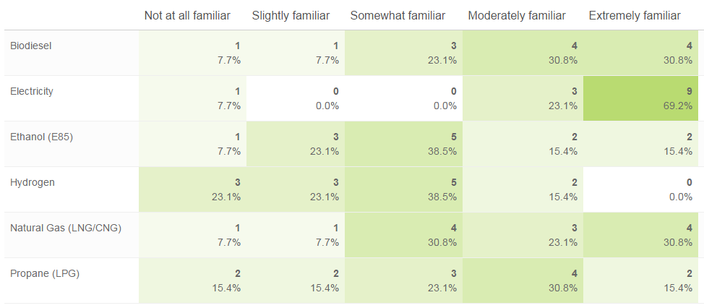
Out of the local fleets that were surveyed in the Local Fleet Alternative Fuel Survey (Fleet Survey), those that had adopted alternative fuels into their fleets expressed the most familiarity with natural gas, propane, and biodiesel. Fleets that had not adopted any alternative fuels, expressed little familiarity with alternative fuel types. Adopting fleets’ familiarity with alternative fuels can be found in Figure 3-2.

  - Figure 3-2: Familiarity with Alternative Fuels Among Adopting Fleets
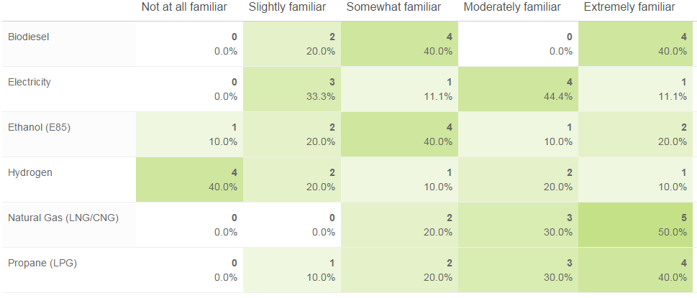

4. State and Municipal Strategies
There are many state goals, policies, and mandates intended to increase the use of alternative fuel vehicles and support the installation of alternative fuel infrastructure. Local governments and public agencies in tune with these policies will be able to stay at the forefront of grant opportunities from the state.

State Strategies
Many of the state goals, policies, and mandates to increase the use of alternative fuel vehicles and support the installation of alternative fuel infrastructure are listed in Table 4-1. These strategies drive state activities and programs, and allocate money to projects expected to propel the alternative fuel market forward.

Table 4-1: Alternative Fuel-Oriented Strategies
Strategy Origin | Year | Objectives | Goals and Milestones
Federal Clean Air Act | 1970 | Air Quality | 80 percent reduction of NOx by 2023
AB 2076 (Shelley) | 2000 | Petroleum Reduction | Increase use of alternative fuels to 20 percent of on-road transportation fuel use by 2020 and 30 percent by 2030
AB 1493 (Pavley regulations) | 2002 | GHG Reduction | 17 percent reduction in climate change emissions from light-duty fleet by 2020 and 25 percent overall reduction by 2030
Petroleum Reduction and Alternative Fuel Goals (Reducing California’s Petroleum Dependence) | 2003 | Petroleum Reduction | Reduce petroleum fuel use to 15 percent below 2003 levels by 2020
AB 1007 (State Alternative Fuels Plan) | 2005 | GHG Reduction | Increase alternative fuel use to 9 percent by 2012, 11 percent by 2017, and 26 percent by 2022; helps meet AB 1007
Energy Policy Act of 2005; Energy Independence and Security Act of 2007 | 2005 | Renewable Fuel Standard | 36 billion gallons of renewable fuel used in the US by 2022
Executive Order S-3-05 | 2005 | GHG Reduction | By 2010, reduce GHG emissions to 2000 levels; by 2020, reduce GHG emissions to 1990 levels; by 2050, reduce GHG emissions to 80 percent below 1990 levels
AB 32 (Global Warming Solutions Act) | 2006 | GHG Reduction | Reduce GHG emissions to 1990 levels by 2020
Executive Order S-06-06 (Bioenergy Action Plan) | 2006 | In-State Biofuels Production | Produce in California 20 percent of biofuels used in state by 2010, 40 percent by 2020, and 75 percent by 2050
Low Carbon Fuel Standard | 2007 | GHG Reduction | 10 percent reduction in carbon intensity of transportation fuels in California by 2020
Executive Order B-16-2012 | 2012 | ZEV Mandate | Accommodate 1 million zero-emission vehicles by 2020 and 1.5 million by 2025
Governor Brown Inaugural Address 2015 | 2015 | Petroleum Reduction | Reduce petroleum use in cars and trucks by up to 50 percent within the next 15 years (2030)
Chart adapted from Smith, Charles, & McKinney, Jim. 2013. 2014-2015 Investment Plan Update for the Alternative and Renewable Fuel and Vehicle Technology Program Commission Report (CEC-600-2013-003-CMF)
These State and Federal strategies set policies and goals for the increased use of alternative fuels in California. Significantly, AB 32, which seeks to reduce GHG emissions to 1990 levels by 2020, has played a large role in setting the stage for California to address climate change and has created a strong impetus for future GHG-reducing legislation.
According to the Public Agency Survey, the majority of respondents were familiar with AB 32, which may be due to their experience with GHG inventories and climate action planning. Despite the majority of respondents having identified themselves as “extremely familiar” with electricity (see Figure 4-1), fewer than one third of respondents were familiar with Governor Executive Order B-16-2012, which set a goal to build enough infrastructure to accommodate one million electric vehicles on state roads by 2020.
  - Figure 4-1: Public Agency Respondents’ Familiarity with State Strategies
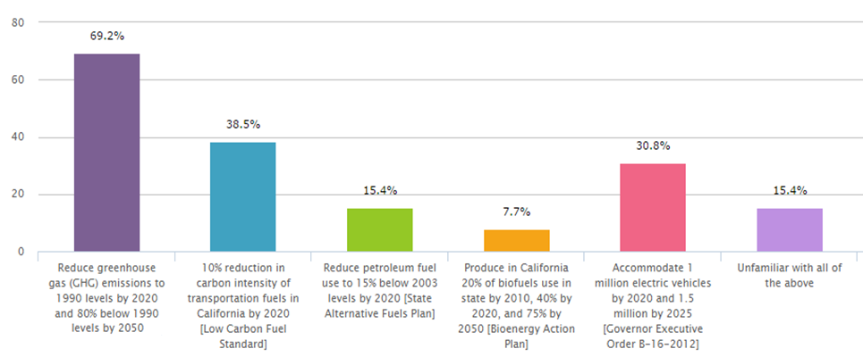

Status of the State Alternative Fuels Plan
AB 1007, the State Alternative Fuels Plan, called for the reduction of petroleum use to 15 percent below 2003 levels by 2020 and 30 percent by 2030. In order to achieve this target, alternative fuel use needed to make up 9 percent of California’s total fuel consumption by 2012, 11 percent by 2017, and 26 percent by 2022.
The Integrated Energy Policy Report (IEPR) is developed by the Energy Commission and adopted every two years and an updated in alternate years. It provides recommendations for ways California can reduce its GHG emissions while satisfying its energy needs. According to IEPR research presented at an Energy Commission Joint Lead Commissioner Workshop on Transportation Energy Demand Forecasts, Gary Yowell, Associate Automotive Standards Engineer at the Energy Commission, surmised that, despite its progress, the State has missed AB 1007’s 2012 milestone by 360 million gallons, and, should this trend continue, the 2017 milestone would be short by 360 to 550 million gallons. Estimates by the Environmental Defense Fund also show that California’s growing fuel diversity will still only comprise 15 - 24 percent of the fuel market in 2020. A depiction of this trend can be seen in Figure 4-2.
The 2014 IEPR notes that in order for California to meet its clean air goals, there needs to be continued transformation of the transportation system to accept zero- and near-zero emission technologies. It found that the California PEV market, growing hydrogen fuel cell market, and biofuels investment are making considerable progress to achieving the state’s climate goals.

  - Figure 4-2: Alternative Fuels and Alternative Fuel Vehicles Fuel Use as a Percent of Total Fuel Demand
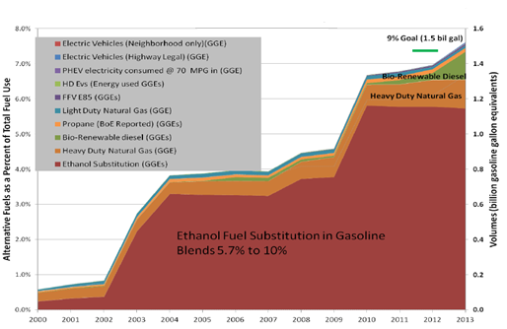
Yowell, Gary. “Historical Trends and Petroleum Reduction Technologies Performance.” Presentation, California Energy Commission, Sacramento, CA, August 21, 2013
The primary increase in alternative fuel use in California is the result of ethanol fuel substitution in gasoline (as a required oxygenate in reformulated gasoline). Figure 4-2 illustrates that despite aggressive strategies meant to reduce petroleum consumption and increase alternative fuel production and use, the state is still falling behind in reaching its milestones.
On January 5, 2015, Governor Jerry Brown delivered his inaugural address for his fourth term in office and reinforced California’s aggressive energy strategies. Specifically, the Governor called for reducing petroleum use in cars and trucks by 50 percent by 2030, keeping the State on track towards achieving the strategies established by AB 32. Satisfying AB 32 will come from a combination of increased investments in alternative fuels, reduced vehicle miles traveled, and increased fuel efficiency.

Status of Bioenergy Action Plan
The State’s Bioenergy Action Plan (2006) identified three milestones for the State to reach: 20 percent of biofuels used in state should be produced within the state by 2010, 40 percent by 2020, and 75 percent by 2050. Despite the benefits of increasing biofuel production to the state’s economy and environment, the state is not on track to meet these goals.
The 2011 Bioenergy Action Plan Update (Action Plan) noted the difficulty of California reaching any biofuel consumption milestone due to siting and permitting, economics and financing issues, and regulatory issues. To meet Action Plan milestones, the state would need to produce up to 1.28 billion gallons of biofuel (850 million gallon gas equivalent, GGE) per year by 2020. In 2009, in-state biofuel production made up only 5.8 percent of California’s one billion GGE of biofuel demand, producing about 48 million GGE of biofuels.
As a result of the Action Plan’s recommendations for increased biofuel production, the University of California, San Diego received a three-year, $2 million research grant in 2011 from the Energy Commission to accelerate biofuel research. The Energy Commission also has funded San Diego-based biodiesel producer New Leaf Biofuel to expand its production capacity to five million gallons per year.

Status of Executive Order B-16-2012
Governor Brown issued Executive Order B-16-2012, which set a goal to getting 1.5 million zero-emission vehicles (ZEV) on California’s roads by 2025. By the first quarter of 2015, there were approximately 100,000 ZEVs in California; leaving ten years to add the remaining million ZEVs.
According to a 2013 Energy Commission workshop on Electricity and Natural Gas Demand Forecasts, at the current rate of growth, California will reach 1.5 million ZEVs one year later than the goal date – in 2026. This forecast is based on a “best case” scenario, which is depicted in red in Figure 4-3. It factors in forcasted crude oil prices, future costs of light-duty vehicles, and CAFE standards. If the trend in ZEV adoption continues with business–as-usual, the 1.5 million ZEV milestone will be reached much later.
  - Figure 4-3: Preliminary Forecast of On-Road PEVs
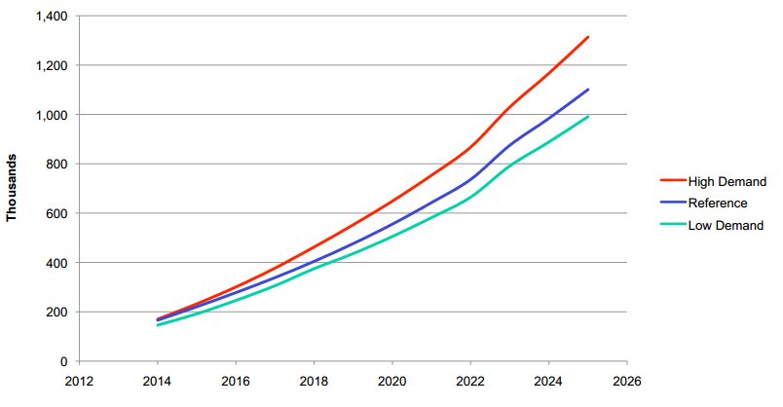
Graph adopted from Olson, Tim. “Preliminary Electric Vehicle Demand Forecast: Workshop on Revised Electricity and Natural Gas Demand Forecasts 2014-2024.” Presentation, California Energy Commission, October 1, 2013

Local Climate and Sustainability Planning
In order for California to meet its alternative fuel goals, it is imperative that counties and cities try to achieve similar alternative fuel goals at the local level. Several municipalities in the San Diego region have completed energy or sustainability planning documents or Climate Action Plans (CAPs) which detail recommendations and strategies to reduce GHG emissions.
The following chart shows CAPs, sustainability plans, energy roadmaps, or other energy planning documents that have been adopted by local jurisdictions and local public agencies in the San Diego region, and address alternative fuel vehicles as a strategy to reducing GHG emissions. Though these planning documents vary in scope, they signal a commitment to increasing alternative fuel use. Of the region’s 18 cities and the County of San Diego, many have planning documents that list alternative fuel vehicles and/or infrastructure as a means of reducing GHG emissions.
According to the Public Agency Survey, 69 percent of respondents noted alternative fuels as a key substitute to conventional fuels in their CAP or other planning or fleet management policy document. Table 4-2 shows specific alternative fuel strategies that the region’s jurisdictions have either adopted or drafted in a planning document. The number of CAPs and other policy documents throughout the region that call for increased alternative fuel use as a means for reducing GHG emissions illustrates the demand for the toolkits to be develop by Refuel to help achieve these goals.

Republic Services Chula Vista uses CNG and biodiesel trucks in support of the City’s climate goals.

Table 4-2: San Diego Regional Alternative Fuel Strategies
Jurisdiction | Year Adopted | Alternative Fuel Strategy
Chula Vista | 2008 | 100 percent clean vehicle replacement policy for city fleet. [CAP]
Chula Vista | 2008 | 100 percent clean vehicle replacement policy for city-contracted fleet services. [CAP]
Encinitas | 2011 | Obtain alternative fuel vehicles and more fuel efficient fleet vehicles for the city. [CAP]
Escondido | 2013 | Substitute electric landscaping equipment for traditional gas-powered equipment. [CAP]
Escondido | 2013 | Use electric or natural gas-powered construction equipment in lieu of gasoline or diesel-powered engines, when feasible. [CAP]
La Mesa | 2012 | Encourage infrastructure, such as fueling stations, for alternative fuel vehicles. [General Plan]
National City | 2011 | Develop streamlined permitting requirements, standardized design guidelines and siting criteria for all types of EV charging stations. [CAP]
National City | 2011 | Continue to integrate alternative transportation fuels and vehicles into the government fleet and the fleets of contractors. [CAP]
Port of San Diego | 2013 | Support and promote the use of alternative fueled, electric, or hybrid Port owner vehicles and vessels (also includes cargo handling equipment, terminal and stationary equipment). [CAP]
City of San Diego | 2011 | The City will commit to investigate the benefit, availability and use of lower carbon fuels, low emission & zero emission vehicles, including but not limited to Super Ultra Low Emission Vehicles (SULEV), Partial Zero Emission Vehicles (PZEV) and Zero Emission Vehicles (ZEV) such as electric vehicles. [Fuel Reduction and Transportation Efficiency Policy 90.73]
County of San Diego | 2011 | All vehicles purchased for the County of San Diego’s fleet will be the most fuel-efficient and lowest emissions within the vehicle class/type. [Policy H-2]
San Marcos | 2013 | Reduce GHG emissions associated with the City's vehicle and equipment fleet by 15 percent below 2005 levels by 2020 and 21 percent below 2005 levels by 2030. Have a total of 12 vehicles replaced by 2030. [CAP]
San Marcos | 2013 | Achieve a 2 percent reduction in light-duty vehicle emissions above Advanced Clean Car Standards in 2020 and a 5 percent reduction in 2030. Achieve a switch of 10 percent of heavy-duty vehicles to use alternative fuels by 2020 and 20 percent switch to alternative fuels by 2030. [CAP]
San Marcos | 2013 | 5 percent of construction vehicles and equipment should utilize new technologies, CARB-approved low carbon fuel, or be electrically-powered by 2020 and 15 percent by 2030. [CAP]
UC San Diego | 2008 | Replace gasoline-powered vehicles with alternatively-fueled vehicles.[CAP]
UC San Diego | 2010 | An objective of the University is to reduce the number of internal combustion engines (ICEs) on campus by converting to neighborhood electric vehicles or other electric vehicles that are certified and licensed for on-road operation. [Policy and Procedure Manual 551-2]
Vista | 2012 | Continue to convert city fleet to more fuel-efficient and alternative fuel vehicles on a replacement basis. [CAP]
Carlsbad | In Progress | Promote an increase in the amount of ZEV miles traveled from a projected 15 percent to 25 percent of total vehicle miles traveled by 2035.[CAP]
Carlsbad | In Progress | Increase the proportion of fleet low and zero-emissions vehicle miles traveled to 25 percent of all city-related VMT by 2035. [CAP]
City of San Diego | In Progress | Increase the number of zero-emission vehicles in the municipal fleet to 50 percent by 2020 and 90 percent by 2035. [CAP]
City of San Diego | In Progress | 100 percent conversion from diesel fuel used by municipal solid waste collection trucks to compressed natural gas or other alternative low emission fuels by 2035. [CAP]
City of San Diego | In Progress | Install and leverage installation of a network of 6,000 charging stations by 2020 and 30,000 by 2035, sufficient to support electric vehicle use equivalent to 4 percent of total miles driven by 2020 and 25 percent by 2035. [CAP]
Solana Beach | In Progress | Adopt electric vehicles into city fleet [CAP]
Santee | In Progress | Will look to adopting more hybrid and alternative fuel vehicles as replacements are needed. [CAP]

Aside from jurisdiction-specific climate and energy planning, SANDAG offers the Energy Roadmap Program, which provides energy management plans to its member agencies. All eligible jurisdictions are participating in the Energy Roadmap Program with the majority having completed Energy Roadmaps (Roadmap). Each Roadmap provides a personalized framework for a local government to reduce energy use in their municipal operations and community. Within each Energy Roadmap is a chapter devoted to “Greening the City Vehicle Fleet,” emphasizing how alternative fuel vehicles can help cities achieve transportation-related energy savings goals and reduce petroleum use.
Since the completion and adoption of the Regional PEV Readiness Plan in early 2014, 61 percent of Public Agency Survey respondents have used the PEV Readiness Plan as a guidance document when developing strategies or policies. However, only 30 percent have actually implemented some of the PEV Readiness Plan’s recommendations and/or incorporated them into their jurisdiction’s policies and/or practices.
Among the several planning documents available and developed by jurisdictions, there are key strategies that are prevalent among them all, which include:
- Replacing vehicles in government and contractors’ fleets with alternative fuel vehicles
- Increasing the number of alternative fuel stations available for the public
- Increase the number of alternative fuel vehicles in government fleets
- Streamlining permitting for alternative fuel infrastructure

San Diego Region Greenhouse Gas Reductions
The San Diego region is progressing toward petroleum reduction goals similar to those of the State. While the region does not have defined petroleum reduction mandates, the region could follow the general guideline set forth by AB 1007, to reduce petroleum fuel use to 15 percent below 2003 levels by 2020. Table 4-3 shows the theoretical reductions the region as a whole would need to achieve in order to reach the State’s petroleum reduction target.

Table 4-3: Theoretical San Diego Regional Petroleum Reduction Goals
Category | 2011 | 2020 Forecasted | 2020 Targets | Reductions to Reach Targets
Number of Vehicles | 2,684,261 | 3,235,795 | n/a | n/a
Gasoline and Diesel Consumption (gal) | 1,398,552,571 | 1,377,129,080 | 1,236,408,810 | 140,720,270

There would need to be a 141 million gallon reduction in gasoline and diesel consumption in the region by 2020 in order to reach 15 percent below 2003 levels. From 2011 to 2013, SDRCCC stakeholders have reduced over 13 million gallons of petroleum (see more in Vehicles). However, the region can help the state reach this ambitious petroleum reduction goal by accelerating the deployment of alternative fueling stations.
In the SANDAG 2009 Report, there is a detailed chapter regarding the full fuel cycle of alternative fuels compared to standard gasoline vehicles, noting how much an alternative fuel reduces GHG emissions and petroleum consumption. The Energy Commission relies on full fuel cycle analyses to qualify alternative fuels for its Alternative and Renewable Fuel and Vehicle Technology Program (see more in Alternative Fuel Investments) and is a tool fleet managers can use in vehicle replacement decisions.

5. Codes and Standards
Alternative fuel stations, like any other built structure, must adhere to local, state, and federal building and permitting codes and standards. Codes dictate requirements on how to safely store, dispense, and build public and private fueling stations, while standards dictate how to meet the code’s requirements. The creation of these codes and standards come from a variety of accepted standards-development organizations. Local governments are usually the enforcers of such codes and may have additional requirements, ordinances or regulations that call for stricter installation procedures than the industry’s codes and standards.

Alternative Fuel Station Installation Codes and Standards
There are a variety of codes and standards regarding every aspect of a fueling station, from its storage containers to installation procedures. The following tables highlight some of the pertinent codes and standards that dictate how to ensure equipment is safe to operate in California.

Biodiesel and Ethanol
The general standards for the dispensing and storage of biodiesel and ethanol fall under the National Fire Protection Association (NFPA) 30 Flammable and Combustible Liquids Code. It covers fire and explosion prevention, storage of liquid in containers, storage systems, and processing facilities. More specific codes and standards for other aspects of biofuel stations are found in the following table. Many of these codes and standards also apply to conventional gasoline fueling stations.
Fueling Station Aspect | Pertinent Codes and Standards
Containers | NFPA 30  American Society for Testing and Materials (ASTM) Standards for Containers  American National Standards Institute (ANSI)/ Underwriters Laboratory (UL) Standards for Containers  US Department of Transportation (DOT) 10CFR49
Dispensing Operations | NFPA 30  NFPA 30A  NFPA 385  NFPA 10
Storage of Liquids | UL 2245, 2080, 2085  NFPA 91, 30A  Steel Tank Institute (STI) Corrosion Control Standards

Electric Vehicle Charging Stations
Electric vehicle charging stations are governed by codes similar to other electrical devices, notably, the National Electrical Code (NEC) 625.
Fueling Station Aspect | Pertinent Codes and Standards
Vehicle and Charger Interface | Society of Automotive Engineers (SAE) J-1772, J-2841, J-2293, J-2847, J-2836
Vehicle Charging Stations | NFPA 70  NEC article 625
Charging Station Components | UL FFTG, UL FFWA

Hydrogen
The general standards for dispensing and storing hydrogen fall under NFPA 2 Hydrogen Technologies Code (National Fire Protection Association, 2011). This set of codes and standards address requirements for hydrogen in compressed gas or liquid forms. It applies to the production, storage, transfer, and safe use of hydrogen in a variety of environments. More specific codes and standards are in the table below.
Fueling Station Aspect | Pertinent Codes and Standards
Storage Tanks/Containers | Gaseous  Compressed Gas Association (CGA) PS-20, PS-21  International Fire Code 2703.2.1, 3003.2, 3503.1.2  NFPA 2  Liquefied  International Fire Code 2703.2, 3203.1, 3203.5, 3203.6, 3204.3.1, 3204.4  NFPA 2
Dispensing Operations | Gaseous & Liquefied  CGA G-5.5  International Fire Code 2204, 2209.4  NFPA 30A
On-site H2 Production | International Fire Code 22099.3.1, 703.1

Natural Gas
The general standards for natural gas fall under NFPA 52 Gaseous Fuel Systems Code. This code addresses the design, installation, compression, storage, and dispensing system of CNG and LNG. It seeks to mitigate the risk of fire and explosion hazards. More specific codes and standards are in the table below.
Dispensing and Storage | Pertinent Codes and Standards
Dispensing Component Standards | NFPA 52  Canadian Standards Association (CSA) NGV 2, 1, 3.1, 4
Dispensing Operations | NFPA 52
Dispensing Vehicle Interface | SAE J1616 RP, J2406 RP
Storage Containers | NFPA 52

Propane
The general standards for propane fall under NFPA 58, Liquefied Petroleum Gas Code. This code addresses the construction, installation, and operation of propane fueling stations and equipment. It seeks to provide safe methods for propane storage, transportation, and use in order to mitigate fires and explosions. More specific codes and standards are in the table below.
Fueling Station Aspect | Pertinent Codes and Standards
Vehicle Fuel Dispense and Dispensing Systems | NFPA 58  UL 567
Storage Containers | NFPA 58  ASME Boiler and Pressure Vessel Code  American Petroleum Institute (API)-ASME Code for Unfired Pressure Vessels for Petroleum Liquids and Gases  CGA C-6  ASCE 7

California Green Building Code
Title 24, the California Building Code of Regulations (California Building Standards Code), includes the California Green Building Standards Code, section 11 of Title 24 – the CALGreen code. The California Building Standards Code is updated every three years and it delineates building code requirements for implementation and enforcement by all cities, counties, and other permitting agencies in California.

  - Figure 5-1: CALGreen Timeline
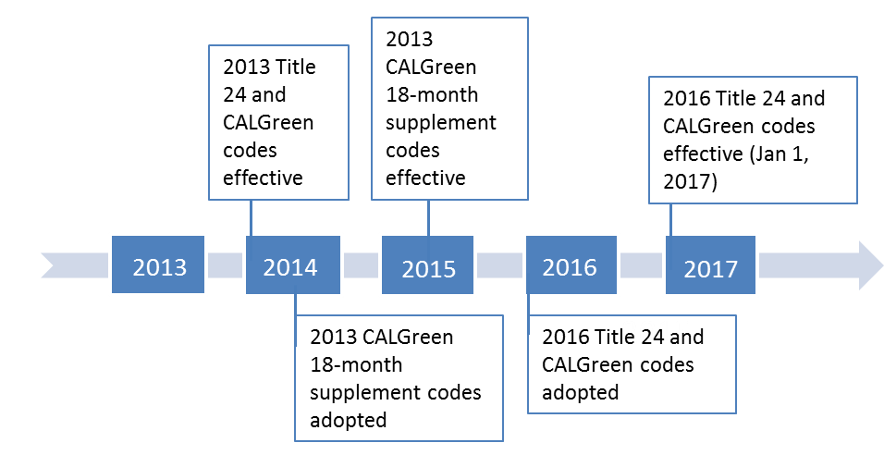
CALGreen mandates that all permitting agencies follow codes that will “improve public health, safety and general welfare by enhancing the design and construction of buildings through the use of building concepts having a reduced negative impact or positive environmental impact and encouraging sustainable construction practices...”. Cities, counties, and permitting agencies may adopt voluntary CALGreen standards or develop their own. In many code scenarios, permitting agencies may adopt voluntary “tiers”—additional requirements that may help jurisdictions further surpass mandatory CALGreen codes.
The 2013 CALGreen code (effective January 1, 2014) does not include mandatory codes for PEV charging in residential or nonresidential buildings; only voluntary codes exist for each. However, the 2013 Intervening Cycle Update, which occurs between each three-year update to include supplements and amendments to the code as necessary, includes mandatory code language for PEV charging, and will become effective July 1, 2015. This update includes the following changes:

Table 5-1: 2013 CALGreen Intervening Cycle Update
Multi-Family Residential
Mandatory | Make at least 3 percent of total parking spaces ready for PEVs (through electrical capacity, building plans, etc.).  - Developments under 17 units exempt
Mandatory | Construction documents should show where electric vehicle charging station (EVCS) are to be located; at least ONE EVCS needs to be located in a common area for use by all residents.
Voluntary | (Tier 1 & Tier 2) Make at least 5 percent of total parking spaces ready for PEVs (through electrical capacity, building plans, etc.).  - Developments under 17 units exempt
Single-Family Residential
Mandatory | Install raceway and electrical panel capacity to support 40 amp capacity electrical circuit.
Voluntary | (Tier 1 & Tier 2) Install complete 208/240-volt branch circuit at minimum 40 amps.
Nonresidential
Mandatory | Install electrical panel capacity to support 40 amp capacity electrical circuit.
Mandatory | If there are more than 50 parking spaces, at least 1 or more must be ready for PEVs, see table below.
Voluntary | (Tier 1) At least 4 percent of parking spaces must be ready for PEVs.
Voluntary | (Tier 2) At least 6 percent of parking spaces must be ready for PEVs.

Zoning and Parking
Zoning and parking codes/ordinances specific to alternative fuels are important as they can streamline the installation of alternative fuel infrastructure. Without specific zoning codes and ordinances, it may become difficult for alternative fuel providers to navigate the station installation process.
In the Public Agency Survey, respondents were asked to provide information about the zoning codes and/or ordinances in their jurisdictions to better understand the process required to install fueling infrastructure. Only one respondent indicated that their agency has zoning codes/ordinances that address alternative fuel infrastructure; specifically, for electric vehicle infrastructure (Figure 4-5). The remaining respondents either were unsure of their jurisdiction’s zoning codes/ordinances or do not have zoning codes/ordinances specific to alternative fuels. The lack of codification for alternative fuel infrastructure highlights the need for toolkit development to help support further fuel deployment.
  - Figure 5-2: Public Agency Respondents with Alternative Fuel Zoning Codes/Ordinances

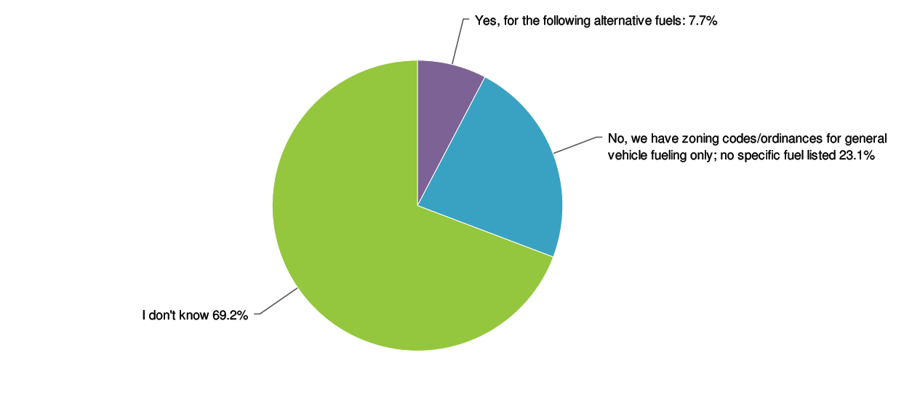
Respondents were also asked whether they had parking codes/ordinances for alternative fuel vehicles. Nearly 40 percent of respondents indicated that their jurisdictions had parking policies for electric vehicles or a policy for general alternative fuel/low-emission vehicles. Another 38 percent had no parking policies for specific alternative fuel vehicles. The remaining respondents were unsure if their jurisdiction had policies that address alternative fuel/low-emission vehicles. Through Refuel and toolkit creation, alternative fuels can be integrated into parking policies.

6. Infrastructure
Alternative fuel infrastructure in San Diego County has seen noticeable growth in the past five years. . Currently, there is at least one public fueling station for each alternative fuel type in San Diego County, with the exception of a hydrogen fueling station, the first of which in the region is expected to be completed early 2016.
In the Public Agency Survey, respondents accurately estimated the amount of fueling stations for half of the fuel types: the number of biodiesel stations was overestimated (three) and propane stations (15) were underestimated. Through the development of the toolkits and Refuel, increased awareness of the DOE Alternative Fuel Data Center (AFDC) can increase local knowledge of available alternative fuel stations.

The Alternative Fuel Data Center’s station locator tool provides local station information for all alternative fuels.
The AFDC is an online clearinghouse of information on advanced transportation technologies. AFDC is sponsored by the DOE Clean Cities program and produced by the National Renewable Energy Laboratory (NREL). AFDC consists of resources and tools to help companies, fleets, public agencies, and consumers learn about and employ petroleum-reduction technologies and measures.
AFDC maintains a station locator tool which contains current public and private alternative fuel stations throughout the United States. Using data from the AFDC station locator, the following charts show the development of alternative fuel infrastructure within San Diego County from 1991 to 2014.

  - Figure 6-1: Public Alternative Fuel Stations
San Diego County, 1991-2014
Alternative Fuel Data Center. “Alternative Fueling Station Locator.” Last updated January 21, 2015. http://www.afdc.energy.gov/locator/stations/
To date, propane has about 15 public stations in the San Diego region, CNG has 8 and biodiesel has three. As a first market (or early market) for PEV deployment by major Original Equipment Manufacturers (OEMs) in 2010, the region has seen steady growth in electric vehicle charging stations. As of April 2015, the region is home to 549 public charging stations (Level 2 and DC Fast Charge, DCFC) and numbers continue to grow.

  - Figure 6-2: San Diego County Public Level 2 Electric Vehicle Charging Stations
Alternative Fuel Data Center. “Alternative Fueling Station Locator.” Last updated January 21, 2015. http://www.afdc.energy.gov/locator/stations/

Infrastructure Coverage
Though a large number of alternative fuel stations is a positive indicator of greater alternative fuel use, these stations may be left unused if they are not strategically placed among residences and businesses.
Through an analysis of the location of alternative fuel infrastructure in San Diego County, SDRCCC was able to determine how many residences and businesses can be served by a given alternative fuel station. Table 6-1 shows the percentage of San Diego County residences and businesses that are within a five mile radius of an alternative fuel station.

Table 6-1: Alternative Fuel Station Coverage
 | All Residences | All Businesses
CNG | 47 percent | 57 percent
Propane | 66 percent | 78 percent
Ethanol | 48 percent | 50 percent
Biodiesel | 29 percent | 35 percent
Electric (DCFC) | 78 percent | 88 percent

As seen in Table 6-1, San Diego County’s network of DCFC stations are accessible to the highest percentage of residences and businesses in the region. Seventy-eight percent of the county’s residences and 88 percent of the region’s businesses are located within five miles of a DCFC station. The region’s propane stations are also accessible to a large portion of residences and businesses, 66 percent and 78 percent respectively. Biodiesel stations cover the lowest percentage of the region’s residences and businesses at 29 percent and 35 percent, respectively.
Coca-Cola will install electric vehicle charging stations across seven of its CA facilities in 2015
According to the Energy Commission, the San Diego region would need to host up to 4,200 public Level 2, 190 public Level 1, and 138 public DC fast charging charge points in order to support California’s 2025 1.5 million ZEV goal., Currently, there are a little over 500 public charging points in the region, highlighting the continued support needed to increase the deployment of charging stations throughout the region.
The number of CNG refueling stations necessary to support associated vehicles is equivalent to 10 - 20 percent of traditional retail gasoline stations. There are approximately 1,000 traditional gas stations in the region, with approximately ten CNG fueling stations.

7. Vehicles
In 2014, there were close to 2.3 million light-duty vehicles in San Diego County and nearly 60,000 heavy-duty vehicles.. Statewide, there were 26 million light-, medium-, and heavy-duty vehicles. The region accounts for nearly 9 percent of the state’s total vehicle population. The number of vehicles in the region is growing at rate of approximately one percent per year.
The following figures show the San Diego regional alternative fuel trends in comparison to the State as a whole. Figure 7-1 shows the growth of light-duty alternative fuel vehicles from 2000 to 2012. The data shows that flex fuel, conventional hybrids, and diesel vehicles have been the most widely adopted alternative fuels in the state. The San Diego region has experienced similar trends.

  - Figure 7-1: Light-Duty Registered Alternative Fuel Vehicle Populations
California, 2000-2012
Eggers, Ryan. “Trends in Transportation Energy Consumption.” Presentation, California Energy Commission, Sacramento, CA, September 9, 2011. & Yowell, Gary. “Historical Trends and Petroleum Reduction Technologies Performance.” Presentation, California Energy Commission, Sacramento, CA, August 21, 2013
From 2010 to 2014, the region’s light-duty alternative fuel vehicle market was predominantly led by sales of flex fuel, hybrids, and diesel. Approximately 80 percent of the region’s new light-duty vehicle sales continue to be for traditional gasoline vehicles.

  - Figure 7-2: New Alternative Fuel Light-Duty Vehicle Sales
San Diego County, 2010-2014
Data from National Renewable Energy Laboratory analysis, R.L. Polk, POLK_VIO_DETAIL_2014, January 2015.
Diesel has been the predominant fuel for use in medium- and heavy-duty vehicles, comprising approximately 65 percent of medium- and heavy-duty vehicles sales from 2010 to 2014.
Though diesel has historically been regarded as a “dirty” fuel, emissions control technology has improved greatly in the last decade. In 2006, California began the transition to Ultra Low Sulfur Diesel, allowing the use of particulate filters that highly reduce particulate matter (PM). Further, technologies such as Selective Catalytic Reduction (SCR) allow diesel engines to decrease exhaust emissions by up to 90 percent. Current regulations ensure that the state’s diesel fleet will transition to these new technology engines over the next ten years.

  - Figure 7-3: New Medium- and Heavy-Duty Vehicle Sales
San Diego County, 2010-2013
Data from National Renewable Energy Laboratory analysis, R.L. Polk, POLK_VIO_DETAIL_2014, January 2015.
Figure 7-4 shows the average yearly gasoline price in California between 2010 and 2014 with San Diego County’s alternative fuel light-duty and gasoline light-duty vehicle sales.

  - Figure 7-4: San Diego Regional Alternative Fuel Vehicle Sales and Gasoline Prices
U.S. Energy Information Administration. “Weekly Retail Gasoline and Diesel Prices.” California. http://www.eia.gov/dnav/pet/pet_pri_gnd_dcus_sca_a.htm
The data does not show a strong indication that an increase in gas prices led to decreased gasoline vehicle purchases or increased alternative fuel vehicle purchases in the region in the year 2014, San Diegans used 1.6 billion gallons of gasoline, costing them $6.06 billion.
While the San Diego region has witnessed a steady rise in the number of alternative fuel vehicles, the most significant increase is seen among PEVs, as shown in Figure 7-5. The sharp increase in PEVs between 2012 and 2014 coincides with the increase in vehicle choices.

  - Figure 7-5: Estimated Cumulative PEV Sales
San Diego County, 2010-2014

In the four years since PEVs were introduced, they now hold roughly one percent of the region’s passenger vehicle market. Recently, PEVs have held close to five percent of California new car sales. In the San Diego region, there are over 10,000 PEVs.
Poway Unified School District has 35 CNG school buses

Alternative Fuel Vehicles in Local Fleets
Since 2004, the SDRCCC has maintained regional data on the use of alternative fuels and the deployment of alternative fuel vehicles in local fleets. Figures 7-6 and 7-7 depict the growth of alternative fuel vehicles in the region as well as the yearly gallons of gasoline equivalent reduced by SDRCCC stakeholders as a result of the adoption of alternative fuel vehicles.
  - Figure 7-6: Number of Alternative Fuel Vehicles from SDRCCC Stakeholders

Figure 7-7 depicts the number of gallons of gasoline equivalent reduced by SDRCCC stakeholders from 2011 to 2014 as a result of having adopted alternative fuel vehicles.

  - Figure 7-7: Yearly Gallons of Gasoline Equivalent Reduced by SDRCCC Stakeholders

While the impetus for adopting each alternative fuel differs among fleets, the Fleet Survey identified the following list of motivations from most important to least important:
- Size and types of vehicles I need are available
- I have access to fueling or charging
- Is a public benefit (reduced GHG, pollution, or petroleum)
- Driving range or performance meets fleet’s needs
- Can justify the cost of vehicle, fuel and ownership (tie)
- Vehicles are reliable and maintenance is available (tie)
- Rebates and incentives are available

Table 7-1 identifies the primary motivation for adopting an alternative fuel based on fuel type in a fleet. For instance, hybrid users cited the public benefit of these vehicles as the biggest motivator for adopting the fuel.
  - Table 7-1: Motivations for Adoption by Adopting Fleet Respondents
Fuel Type | Most important motivation
Hybrid | Is a public benefit (reduced GHG, pollution, or petroleum)
Propane | I have access to fueling or charging
Natural Gas | Size and types of vehicles I need are available
Biodiesel | Driving range or performance meets fleet’s needs
Plug-in Hybrid | Driving range or performance meets fleet’s needs
The respondents that have adopted alternative fuel vehicles, also expressed that their biggest challenges or concerns in adding more alternative fuels to their fleet included cost, fuel availability, range, and public participation. Alternatively, the most common reason for respondents to have not adopted alternative fuel vehicles in their fleets was because they could not justify the cost of the vehicle, fuel, and ownership of an alternative fuel vehicle, or that the size and types of vehicles needed are not available. Respondents noted that they feared alternative fuel vehicles would be unreliable or range-limited. However, zero respondents cited range limitations or performance as a reason for not adopting an alternative fuel.
One sector that has seen wide adoption of alternative fuels is public transit. More than 35 percent of U.S. public transit buses use alternative fuels or hybrid technology. Nationwide, new bus orders are close to 50 percent CNG and there are over 10,000 natural gas refuse trucks with more than 55 percent having been new orders. In the San Diego region, nearly 90 percent of transit buses use CNG.

8. Incentives

Incentives are important in order to advance the advanced technology market. Not only do they encourage nascent markets grow when start-up costs are prohibitive, but incentives encourage the adoption of new, clean technology vehicles. Government involvement allows society at-large to reap the benefits of a clean vehicle market. In California, there are several such incentives available to obtain clean technology vehicles.
Since 2010, fleets in San Diego County have received over $4.8 million in funds to procure over 165 clean air vehicles

Heavy-Duty Vehicles
In 2008, the California Air Resources Board (ARB) adopted the California Statewide Truck and Bus Rule, requiring all heavy-duty diesel trucks and buses retrofit or replace engines by 2023 to reduce emissions. To achieve this goal and lessen the financial burden, several programs in California, such as the California Hybrid and Zero-Emission Truck and Bus Voucher Incentive Project, Carl Moyer Program, and Proposition 1B Goods Movement Emission Reduction Program, provide fleets with incentives to replace or retrofit old heavy-duty diesel vehicles and engines.

Hybrid and Zero-Emission Truck and Bus Voucher Incentive Project
The California Hybrid and Zero-Emission Truck and Bus Voucher Incentive Project (HVIP) provide vouchers to facilitate the procurement of low-carbon hybrid and electric trucks and buses. Vouchers range from $8,000 to $45,000, but incentive levels can reach up to $65,000 for certain qualified vehicles and fleets. Since 2010, fleets in San Diego County have received over $4.8 million in funds to procure over 165 clean air vehicles.
  - Figure 8-1: Number of HVIP Vouchers
San Diego County, 2010-2014

San Diego County Air Pollution Control District
The SDAPCD administers funding for two heavy-duty vehicle programs, Proposition 1B Goods Movement Emission Reduction Program (GMERP) and Carl Moyer Voucher Incentive Program (VIP).
GMERP is a partnership between ARB and local air districts to quickly reduce air pollution emissions and health risk from freight movement along California’s trade corridors. Projects funded under this program must achieve early or extra emission reductions not otherwise required by law or regulation. Eligible applications include owners of heavy-duty diesel trucks used in freight movement to upgrade to cleaner technologies. Since 2009, the San Diego region has benefitted from over $22.6 million in funds for truck replacements, retrofits, and repower from GMERP.

Table 8-1: Proposition 1B Goods Movement Emissions Reduction Program Projects in the San Diego Region
GMERP | Diesel | CNG | Propane | Total
Truck Replacement | 434 | 20 | 0 | 454
Truck Repower | 0 | 0 | 47 | 47
Retrofit w/ Diesel Particulate Filter | 70 | 0 | 0 | 70
Marine Repower | 3 | 0 | 0 | 3
Total |  |  |  | 574

VIP provides funding for equipment replacement, engine repowers, engine retrofits, and new purchases. Yearly VIP funding amounts are around $3 million. The VIP provides a streamlined approach to reduce emissions by replacing existing, high-polluting vehicles with newer, lower-emission vehicles or by installing a Verified Diesel Emission Control Strategy (VDECS or “retrofit”). Table 8-2 shows the number of truck replacements made through VIP.

Table 8-2: Carl Moyer Voucher Incentive Program Projects in the San Diego Region
Carl Moyer | Diesel | CNG | Propane | Total
Truck Replacement | 212 | 0 | 0 | 212

There are almost 60,000 heavy-duty trucks and buses in San Diego County: 786 received incentivizes from SDAPCD for cleaner engines

Light-Duty Vehicles
Figure 8-2 shows the amount of funding that the San Diego region has received from ARB’s Clean Vehicle Rebate Project (CVRP), administered by CSE. The CVRP provides up to $5,000 in rebates for the purchase or lease of new, eligible zero-emission and plug-in hybrid light-duty vehicles. During the five-year life of the program, San Diego County has received $17 million, equating to about 7,500 rebates.

Figure 8-2: CVRP Funding in San Diego Region, 2010-2014
Center for Sustainable Energy 2015. California Air Resources Board Clean Vehicle Rebate Project, Rebate Statistics. Data last updated January 22, 2014. http://energycenter.org/clean-vehicle-rebate-project/rebate-statistics
San Diego County has received over $17 million from the CVRP
There are approximately 1.2 million passenger vehicles in San Diego County. Of these passenger vehicles, approximately 10,000 of them are PEVs. Of that number, 7,500 have received a CVRP rebate. As PEVs are a newly introduced passenger vehicle option, they represent a small but rapidly growing percentage of the overall passenger vehicle population.
Overall, it is valuable to promote incentives and funding available for fleets and public agencies to adopt or install alternative fuel vehicles and infrastructure. In both the Public Agency and Fleet Surveys, guidance on the availability of funding for alternative fuel vehicles and infrastructure installation projects were the most desired resources. Notably, 84 percent of public agency respondents, 85 percent of non-adopting fleet respondents, and 75 percent of alternative fuel-adopting fleets selected funding information as a desired resource.

9. Alternative Fuel Investments

California Energy Commission Funding
As established by AB 118 and extended by AB 8, the Energy Commission is responsible for managing the Alternative and Renewable Fuel and Vehicle Technology Program (ARFVTP). This program provides grants to deploy and develop advanced transportation technologies and alternative and renewable fuels that will help the state achieve its climate change mitigation goals. The Energy Commission has an annual program budget of around $100 million to support such projects.
Over $16 million in grant funds have been awarded to entities in the San Diego region to complete advanced technology projects
ARFVTP has funded over 460 clean transportation projects and invested over $531 million in infrastructure and advanced transportation technologies. Primary investments are in electric drive, biofuels, natural gas, hydrogen, workplace development, and market and program development, all of which have supported the increase in alternative fuel vehicles, fuel production, and infrastructure.
Table 9-1 shows how much ARFVTP funding has been invested for projects in the San Diego region since 2011. The variety of projects shows the region’s overall commitment to advancing alternative fuel technology.

Table 9-1: ARFVTP Funding: Awards Given to Projects in San Diego Region
PON # | PON Name | Date Released | Amount Awarded to Local Entity
10-602 | Regional Plans to Support Plug-In Electric Vehicle Readiness | 5/12/2011 | $200,000
11-601 | Biofuels Production Facilities | 1/11/2012 | $3,153,657
11-602 | Alternative Fuels Infrastructure: Electric, Natural Gas, Propane, E85 & Diesel Substitutes Terminals | 2/8/2012 | $1,737,234
12-605 | Natural Gas Fueling Infrastructure | 11/29/2012 | $897,471
13-603 | Alternative Fuel Readiness Plans | 8/12/2013 | $300,000
13-605 | Centers for Alternative Fuels and Advanced Vehicle Technology | 8/23/2013 | $272,263
13-606 | Electric Vehicle Charging Infrastructure | 11/8/2013 | $1,122,855
13-607 | Hydrogen Refueling Infrastructure | 11/22/2013 | $1,451,000
14-603 | Zero Emission Vehicle (ZEV) Readiness | 9/9/2014 | $300,000
14-605 | Medium- and Heavy-Duty Advanced Vehicle Technology Demonstration | 12/19/2014 | $6,884,812
*PON: Program Opportunity Notice |  |  | $16,319,292

Over $16 million in grant funds have been awarded to public agencies, private companies, research institutions, and other entities in the San Diego region to complete advanced vehicle technology projects. As of December 5, 2014, the Energy Commission had provided over $530 million in awards to propel the advanced transportation market across California. In 2015, solicitations for the following project categories are anticipated, in addition to currently open solicitations:

Table 9-2: Anticipated 2015 ARFVTP Statewide Funding
Electric Charging Infrastructure | $6 million
Natural Gas Fueling Infrastructure | $1.5 million
Natural Gas Vehicle Incentives | $10.2 million

In addition to the ARFVTP, AB 8 also established the ARB Air Quality Improvement Program (AQIP). This program funds clean vehicle and equipment projects, including the CVRP, HVIP, and advanced technology demonstration projects. Annual funding for AQIP projects is generally $20 million to $25 million. For the 2015-2016 fiscal year, AQIP will benefit from an additional $200 million from the Greenhouse Gas Reduction Fund (GGRF) derived from the state Cap-and-Trade Program.

U.S. Department of Energy Funding
A number of federal alternative fuel efforts have benefitted the San Diego region including the Clean Cities program, the EV Project, and PEV Community Readiness.
The DOE created the Clean Cities program as a result of the 1992 Energy Policy Act (EPAct), requiring certain vehicle fleets to acquire alternative fuel vehicles. Local Clean Cities coalitions were formed to provide EPAct-regulated fleets with resources to help them abide by the act. Since then, Clean Cities has evolved to help both fleets and consumers reduce their petroleum use. The San Diego Regional Clean Cities Coalition has been working with the community since 1996.
The EV Project was a large-scale effort by ECOtality, to increase the deployment of PEV charging stations across the nation. The initial DOE grant matched $100 million in private capital to establish EV charging infrastructure in five major metropolitan areas including San Diego. The San Diego regional EV Project formed a regional advisory group, developed an infrastructure roll-out plan, and underwent a regional mapping project to identify the most optimal sites for siting EV chargers. Locally, its work contributed to the installation of over 1,400 residential and public Level 2 chargers in the region.
Following the initial deployment of charging stations, the DOE gave 16 awards for PEV community readiness projects, totaling $8.5 million in 2011. California received one million dollars to produce an assessment of community readiness for PEVs. San Diego received a portion of this award to conduct surveys among local jurisdictions and assess barriers to the deployment of PEV infrastructure.
In 2013 CSE was awarded another DOE grant to work with the California Clean Cities Coalitions to conduct an assessment of current and future alternative fuel vehicle training needs for first responders and fleet staff for the Bay Area Air Quality Management District. The report identified the availability of safety and technical trainings in alternative fuel vehicles for emergency personnel and transportation fleet staff in California and provided recommendations for improvement.

Private Funding
In addition to government funding, private funding in the investment of alternative fuel infrastructure and vehicles plays an essential role. The following examples emphasize this value.
Nissan, the vehicle manufacturer of the all-electric LEAF, has been at the forefront of workplace charging station investment. Two of the company’s programs, Workplace Initiative and EV Advantage, provided employers with financial support for installing a charging station at their place of business if they allowed Nissan to host “ride and drives” at their facility. Further, for EV Advantage, Nissan would contribute $10,000 towards the installation of any DC fast charger at a workplace before March 2014.
In 2013, UPS deployed over 100 all-electric commercial vehicles in California
Investments in infrastructure also came from the energy company NRG. NRG is tasked to subsidize the installation of a minimum of 200 public fast chargers – 110 in the Los Angeles region, 55 in the San Francisco Bay Area, 15 in the San Joaquin Valley, and 20 in San Diego County. Since 2012, 13 public fast chargers have been installed in the region.
In 2011, CSE partnered with SDRCCC, SANDAG, and the San Diego International Airport on a $1 million award from the reformulated gasoline settlement fund to launch the San Diego Airport Vehicle Rebate Project (AVRP). This program supported the San Diego International Airport’s goal to transition its ground transportation providers to cleaner vehicles. The project combined extensive education and outreach to ground transportation providers and drivers, along with vehicle funding. The AVRP led to the conversion of 181 conventional gasoline vehicles to hybrid and alternative fuel vehicles. Even with the exhaustion of program funds, vehicle conversions have continued. In early 2015, the SDAPCD approved $360,000 to fund the conversion of the remaining conventional airport taxi cabs to cleaner running vehicles.

10. Training
As the San Diego region continues to support the growth of alternative fuel use, training for first responders, technicians, electricians, and local municipal staff becomes increasingly important.


In the 2013 Needs Assessment of Alternative Fuel Vehicle Training in California, a survey among first responders indicated that there is a strong need for alternative fuel vehicle safety training. Fifty-two percent of the responding fire departments had yet to offer alternative fuel training for their staff.
San Diego MTS will be purchasing over 500 CNG vehicles for their fleet through 2017
Fleet technicians are trained by the manufacturer upon receiving a vehicle; however, due to the 3-5 year vehicle manufacturer warranty, this training often goes unused and in many cases, is lacking by the time they actually need to work on the vehicle. In the Fleet Survey, respondents noted that, along with information on rebates and incentives, maintenance or mechanic training was a very desirable resource to have.
The San Diego region has held a few specialized trainings over the past five years to better prepare for alternative fuels. Specialized trainings include technical training on biodiesel and natural gas, hybrid vehicle technology, and first responder trainings for emergency personnel and for tow truck drivers.
Educational programs such as those provided by the San Diego Miramar College Advanced Transportation Technology and Energy (ATTE) Center offers much of the technical education, training, and resources needed to allow its students to work with advanced, clean fuel technologies. ATTE offers training regularly throughout the year.
Another regularly occurring alternative fuel training is the Electric Vehicle Infrastructure Training Program (EVITP), a training and certification opportunity for electricians who wish to learn how to install electric vehicle service equipment (EVSE). The San Diego Electrical Training Trust (Electrical Training Trust), a partnership of the International Brotherhood of Electrical Workers (IBEW) Local 569 and the San Diego Chapter of NECA and Cuyamaca College have offered EVITP. Since November 2011, the Electrical Training Trust has trained over 60 electricians with the EVITP curriculum and has offered the course three to four times per year since its inception.
As part of the Energy Commission award for PEV readiness planning, the REVI working group hosted an EVITP session for the region in 2012. The session was offered to electricians and city planners.

Municipal Staff Training
In July 2012, the San Diego Area Chapter of the International Code Council and the San Diego Chapter of the NECA hosted a seminar on PEV infrastructure installations for over 60 San Diego regional building code inspectors, local government staff, and industry professionals. This training covered NECA requirements for various PEV infrastructure installations in order to abide by NEC rules and safety standards.
Some training on codes and permitting for alternative fuel infrastructure and vehicles has taken place in the region but insuring this training continues is critical to maintaining current on code and permitting changes and opportunities. The regional alternative fuel readiness planning grant is helping to identify training needs as well as the implementation of the PEV regional readiness plan. In November 2014, SANDAG received a grant from the Energy Commission that will allow the region to continue work initiated by the REVI working group, to offer code and permit training and support for electric vehicle infrastructure.

11. Outreach and Education
Community outreach and education help eliminate misconceptions and fosters awareness surrounding alternative fuels. SDRCCC hosts several yearly events intended to increase the community’s awareness and knowledge on alternative fuels, as shown in Table 11-1. Other agencies in the region also support alternative fuel deployment through more specific events, ranging from local government meetings or community workshops. According to the Public Agency Survey, 69 percent of public agency respondents learned about alternative fuels through workshops or conferences.

Table 11-1: San Diego Regional Clean Cities Coalition Workshops and Events, 2012-2014
Clean Cities Workshops/Events | # People Reached
2014
Reducing Transportation Emissions | 30
Steering San Diego Forward with Clean Mobility | 21
Alternative Fuels Best Practices | 40
2013
Options and Opportunities for Alternative Fuels | 37
Focus on: Biofuels | 50
Moving Goods and People In and Throughout the Region | 45
Focus on: Propane | 30
Focus on: Plug-in Electric Vehicles | 67
Plug-in Electric Vehicle Dealer Workshop | 17
Focus on: Natural Gas | 13
2012
Odyssey Day | 70

Another critical component for increasing alternative fuel vehicle awareness is through car dealership education. Dealers, who often influence vehicle purchases, do not necessarily know details about alternative fuel vehicles offered by their OEM. If dealers are armed with information to better understand and communicate with consumers about clean air vehicles, the region can be better served.
CSE conducts quarterly webinars about the CVRP to dealers. The webinars cover program updates, basics about the CVRP, how to apply for a rebate, and other incentives available for consumers. This helps dealers who have CVRP-eligible vehicles stay up-to-date about the incentive program and helps prevent misinformation from being relayed. SDG&E has also presented to the local new car dealership association on electric vehicle options, electric rates, and other relevant information.
SDRCCC also has contributed towards increasing local dealers’ knowledge of alternative fuel vehicles. In 2014, SDRCCC developed two sets of marketing material: a brochure about PEVs and a flier about flex fuel. In just three months, 850 flex fuel fliers and 3,260 dealer brochures were distributed. Additionally, SDRCCC has worked with biofuel companies in the region to help promote general awareness of biofuel and the location of local biofuel stations.

12. Data Limitations
When compiling information for the Assessment, there was limited data available about alternative fuel vehicles in the State and, to a greater extent, the San Diego region. The California Air Resources Board provides useful tools such as the On-Road Vehicle Emissions Factors Model (EMFAC), which was used several times in the development of the Assessment; however, EMFAC does not capture any details about alternative fuel vehicles. Energy Commission workshop presentations helped to provide high-level information about the State’s progress towards various alternative fuel goals, but their raw data was inaccessible.
It is difficult to find San Diego-specific data for alternative fuel vehicles. Most of the region’s vehicle inventories come from State tools, which can’t provide precise information for a given region.
Third party resources such as Polk and Department of Motor Vehicle (DMV) data are also incomplete. DMV vehicle categorization often confuses alternative fuel vehicles for its gasoline counterpart (for example, a Volkswagen e-Golf versus the Volkswagen Golf) and may lack the necessary detail to properly differentiate between the types. Further, it has proven difficult to acquire historical data making inferences about long-term trends nearly impossible.
The CVRP has served as a proxy for actual PEV data, recognizing that not all PEV purchasers apply for a CVRP rebate for various reasons. Together with Polk, state agency data, SDRCCC data, and surveys, these disparate information sources have been useful in combination to provide some level of regional alternative fuel vehicle data. Data remains an issue that the state could help to enhance.

13. Alternative Fuel Barriers
The Alternative Fuel Barriers Table, found in Appendix B, details the obstacles identified by Refuel, currently facing the San Diego region’s ability to increase alternative fuel use. In all, there are three general themes under which the barriers fall: education, infrastructure, and vehicles.
Education barriers detail lack of available information or important alternative fuel resources available. The barriers address the need for more training and education for municipal staff, emergency personnel and transportation fleet staff, and the general public.
Alternative fuel infrastructure barriers detail obstacles that impede the further deployment and installation of alternative fuel infrastructure. These barriers address codes and permitting, site assessments, outreach about public infrastructure, infrastructure costs, and EVSE at workplaces and multi-unit dwellings (MuDs).
Lastly, alternative fuel vehicle barriers detail obstacles that prevent the procurement of alternative fuel vehicles. These barriers address how to select appropriate alternative fuel vehicles, financing vehicles, converting conventional vehicles to alternative fuels, and inhibitions about future alternative fuel technology.
Specific recommendations for inclusion within toolkits have been identified for each barrier. These recommendations incorporate lessons learned from public agency and fleet survey results as well as the conclusions from the Assessment. Further, the recommendations seek to further arm the community with relevant information in order to encourage the San Diego regional alternative fuel market forward.

14. Conclusion
With the proper tools and support, the San Diego region can serve a diverse network of alternative fuel stations and vehicles. The region is well-primed to become a leader across alternative fuels and associated vehicle markets.
Alternative fuels can play a larger role in the San Diego region in support of local, state, and federal policies to reduce petroleum dependence, GHG emissions and other pollutants. The biggest barriers concern the lack of proper information and knowledge among the community regarding alternative fuels, the high cost of vehicles, and lack of refueling infrastructure. As a region, San Diego has become a leading electric vehicle market, boasting hundreds of public chargers and thousands of PEVs on the roads.
The region has become a PEV-friendly place due to a combination of local engagement, public-private partnerships, public funding, and a substantial population of early adopters. Some sectors already have high alternative fuel penetration, such as transit and refuse where natural gas busses and trucks now represent the majority of vehicles. Private fleets and local municipalities are knowledgeable about alternative fuels – as noted in the survey results, and have interest in integrating alternative fuels into their fleets. Through sector-specific toolkits and the Alternative Fuel Readiness Plan, public agencies and fleets should be able to accelerate the deployment of alternative fuel vehicles and infrastructure in the San Diego region.
In response to the Assessment, Refuel should consider the development of the readiness plan and toolkits to accomplish the following:
- Allow consumers to better understand alternative fuel vehicles and provide a baseline understanding of alternative fuel vehicles useful to local governments;
- Allow fleet managers and municipal staff to integrate alternative fuel vehicles and create/promote alternative fuel-friendly policies;
- Train emergency personnel on how to handle alternative fuel vehicles and fleet staff on how to service alternative fuel vehicles;
- Help alternative fuel users how to understand a PEV’s integration with the electricity grid;
- Address common problems that frequently occur when alternative fuel stations are being installed;
- Provide solutions and guidance for municipal staff on where to place fueling infrastructure;
- Develop ways for fuel providers and local jurisdictions to increase awareness of public alternative fuel stations;
- Increase awareness and solutions to charging PEVs at multi-unit dwellings and workplaces;
- Provide public agencies and fleets with tools for evaluating and addressing infrastructure costs;
- Help fleets choose appropriate alternative fuel vehicles for their fleets;
- Provide guidance on procuring and financing alternative fuel vehicles;
- Provide guidance on safely converting conventional vehicles to use alternative fuels;
- Increase awareness of emerging fuels and technologies.

Appendices
(attached)

Energy Policy Initiatives Center (EPIC). 2013. “San Diego County Updated Greenhouse Gas Inventory.” http://catcher.sandiego.edu/items/usdlaw/EPIC-GHG-2013.pdf
More information about the Public Agency Survey, as well as the survey questions, can be found in Appendix C.
More information about the Fleet Survey, as well as the survey questions, can be found in Appendix D.
Reducing California’s Petroleum Dependence, an Energy Commission and ARB, joint agency report, August 2003, publication #P600-03-005.
California Energy Commission. “Joint IEPR Transportation Lead Commissioner Workshop Transportation Energy Demand Forecasts.” Transcript, California Energy Commission. http://www.energy.ca.gov/2013_energypolicy/documents/2013-08-21_workshop/2013-08-21_transcript.pdf
Spiller, Beia, Charles Mason & James Fine. 2013. Impact of California Transportation Policies on Long Term Fuel Diversification, Fuel Producer Market Power, and Motor Vehicle Fuel (Gasoline and Diesel) Prices. Environmental Defense Fund. http://www.edf.org/sites/default/files/sites/default/files/content/Fuels%20Diversification%20Memo%20July%2016%20-%20FINAL.pdf
A gasoline gallon equivalent is the amount of alternative fuel it takes to equal the same energy content as a liquid gallon of gasoline. Using a gasoline-gallon equivalent allows different fuel types to be compared to gasoline. To see how alternative fuels are converted into its gasoline-gallon equivalent, visit http://www1.eere.energy.gov/vehiclesandfuels/epact/fuel_conversion_factors.html
O’Neill, Garry, John Nuffer. 2011. 2011 Bioenergy Action Plan. California Energy Commission, Efficiency and Renewables Division. Publication number: CEC-300-2011-001-CT
Ibid.
McDonald, Kim. 2011. “California Energy Commission Awards UCSD $2 Million for Biofuels Research.” UC San Diego Division of Biological Sciences. http://biology.ucsd.edu/news/article_050511.html.
California Energy Commission. 2013. IEPR Lead Commissioner Workshop Revised Electricity and Natural Gas Demand Forecasts 2014-2024. Transcript.
Corporate Average Fuel Economy (CAFE) standards call for increasing fuel economy of cars and light-duty trucks. Each year the CAFE standard is set for the average new vehicle fuel economy that manufacturers must achieve.
California Motor Vehicle Stock Travel and Fuel Forecast (MVSTAFF) 2010 Report
2013 California Green Building Standards Code, California Code of Regulations, Title 24, Part 11. pg. 1
State of California. Revision Record for the State of California: Supplement 2013 Title 24, Part 11, California Green Building Code. 1 July 2015. https://www.iccsafe.org/cs/codes/Errata/State/CA/5570S133.pdf.
http://www.cafcp.org/stations/san_diego
http://www.afdc.energy.gov
Melaina, Marc, Michael Helwig. (National Renewable Energy Laboratory). 2014. California Statewide Plug-In Electric Vehicle Infrastructure Assessment. California Energy Commission. Publication Number: CEC-600-2014-003.
This is in a “high public access” scenario in which most charging would occur outside of the home. These numbers exclude workplace charging.
America’s Natural Gas Alliance. U.S. and Canadian Natural Gas Vehicle Market Analysis: Compressed Natural Gas Infrastructure Final Report. http://www.anga.us/media/content/F7D3861D-9ADE-7964-0C27B6F29D0A662B/files/11_1803_anga_module5_cng_dd10.pdf
Light-duty vehicle refers to vehicles whose Gross Vehicle Weight Rating (GVWR) does not exceed 14,000lbs. It includes trucks and passenger vehicles.
California Air Resources Board. 2014. Mobile Source Emission Inventory - EMFAC2011. http://www.arb.ca.gov/emfac/.
Polk & Auto Outlook, Inc. 2014. California Auto Outlook. http://www.cncda.org/CMS/Pubs/Cal_Covering_3Q_14.pdf
These numbers do not provide a complete representation of all fleets in San Diego County. All information provided by fleets is voluntary and therefore, the data may be incomplete. SDRCCC stakeholders are fleets and organizations that have participated in Clean Cities events or are in regular communication with the Coalition, and have provided the Coalition with fleet data in its annual fleet questionnaire.
American Public Transportation Association. 2013. “More than 35% of U.S. Public Transit Buses Use Alternative Fuels or Hybrid Technology.” American Public Transportation Association. http://www.apta.com/mediacenter/pressreleases/2013/Pages/130422_Earth-Day.aspx
As of 22 January 2015
California Air Resources Board. 2014. Mobile Source Emission Inventory - EMFAC2011. http://www.arb.ca.gov/emfac/.
http://www.energy.ca.gov/drive/
The Electric Transportation Engineering Corporation. 2013. Q2 2013 Report: The EV Project. http://www.theevproject.com/cms-assets/documents/127233-901153.q2-2013-rpt.pdf.
California Energy Commission. 2012. “CPUC Files Settlement That Will Bring Electric Vehicle Charging Infrastructure to California’s Diverse Communities.” http://docs.cpuc.ca.gov/PUBLISHED/NEWS_RELEASE/165145.htm
Center for Sustainable Energy. 2013. Needs Assessment of Alternative Fuel Vehicle Training in California. http://energycenter.org/sites/default/files/docs/nav/policy/research-and-reports/needs-assessment_for_AFC_training.pdf
EMFAC is a modeling tool created by the California Air Resources Board, which allows for the estimation of emissions from on-road vehicles.

